Thank you for your interest in LiveScore Group and thank you in advance for completing this exercise. We don’t take the use of free time lightly; we really appreciate it. Please be prepared to share your thoughts on the below three questions in a presentation format. Please feel free to use any tools / approaches that you find necessary.

1. The below chart represents the trend of user’s opting in to receive marketing communications over the period of March to May. The trend lines represent the marketing opt-in rate of App traffic only, marketing opt-in rate of Web traffic only, and also the marketing opt-in rate of combined Web + App traffic.   
     
   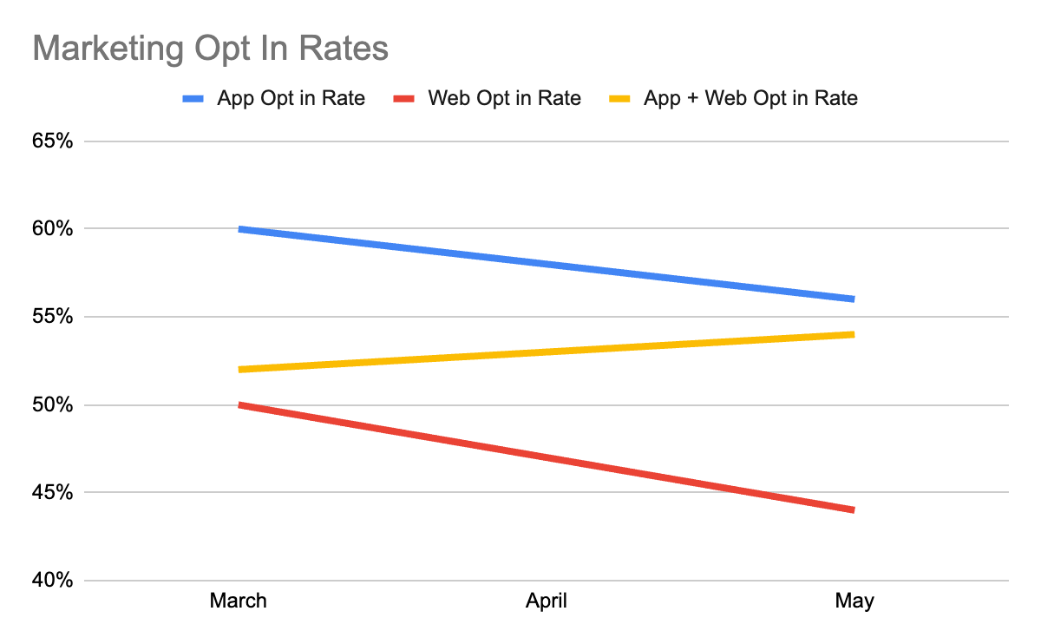  
     
   **Please explain what is happening within this graph.**
2. The attached file dataSourceData.json is a response from our single event API, it returns the data around a single event, such as a football match. In this case it is a football match between Tigre and Deportivo Riestra.  
     
   **a) Write javascript to filter the response so that the script returns an array of Price Boost markets (identified in the feed as Boosted Odds), with all of the information that might be required for use in marketing assets.**  
     
   For reference some of the boosts are:  
   “Tigre, Atletico Tucuman & Defenca y Justicia each to score the 1st goal”  
   “Tigre, Velez & Platense each to win at least one half”

**b) Based on the data returned in dataSourceData.json, propose a new feature that could be used in any kind of marketing campaign and please include any assumptions you make.**

1. The Product Marketing team of LiveScore Media would like to implement features that will allow users to personalise the app based on their favourite team.   
     
   You can use what you know about the LiveScore technology stack, or create an imaginary technology stack, but please outline any assumptions you make in the process.  
   1. **How you would best collect and store this data**
   2. **What tools you would use to process and activate this data**
   3. **Propose a new feature that could utilise this data, giving a brief summary of it, and explaining how it works.**